Online Dialogue Platform-User Guide

Overview of the Dialogue Platform
The Dialogue Platform is a collaborative knowledge and engagement space designed to connect stakeholders across the energy storage ecosystem in India. It enables users to collaborate, share insights, and participate in meaningful discussions.

How You Can Collaborate
Users can participate through discussions, events, and topic creation on the platform.

1. Participate in Discussions
Platform Structure:
- Three main groups: Material, Grid Integration, Economics
- Each group contains subgroups for focused discussions
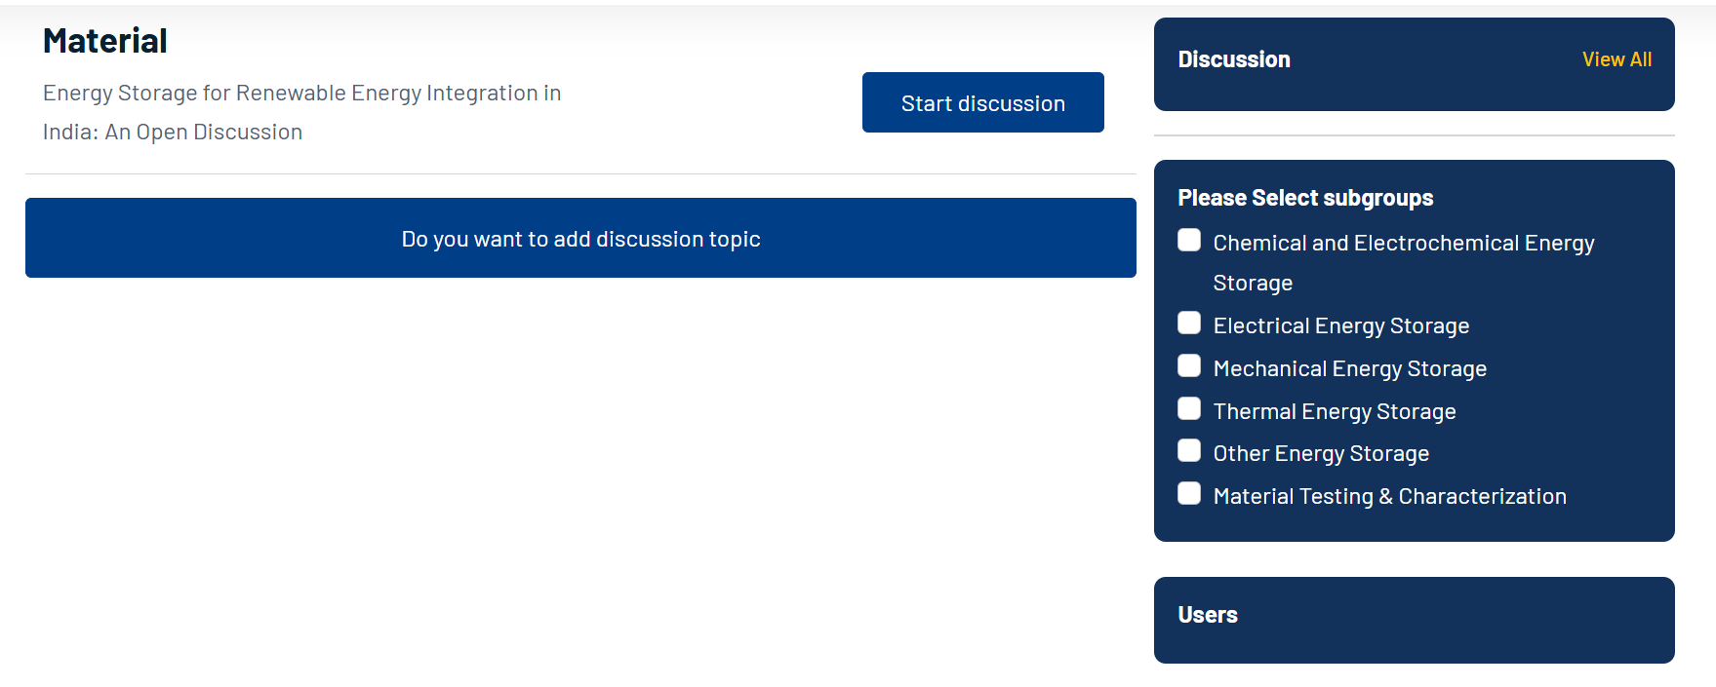

Steps to Participate:
- Login to the platform
- Join a group of your interest
- Navigate to a relevant subgroup
- Start a discussion or respond to existing topics
Note: Posts are published after admin approval.

2. Special Features for Consortium Members
- Initiate new topics directly
- Create closed group discussions (invite-only)

3. Organize and Join Events
- Steps to Create an Event (Webinars, roundtables, thematic discussions)
- Go to the calendar and select the event date for making new entry
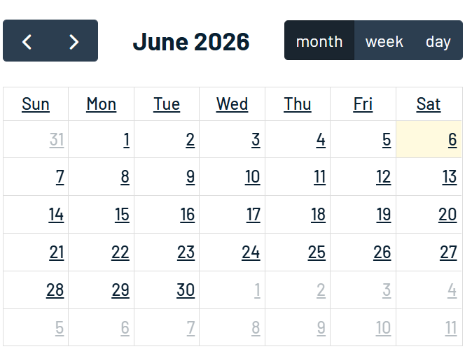
- Fill event details (title, time, description)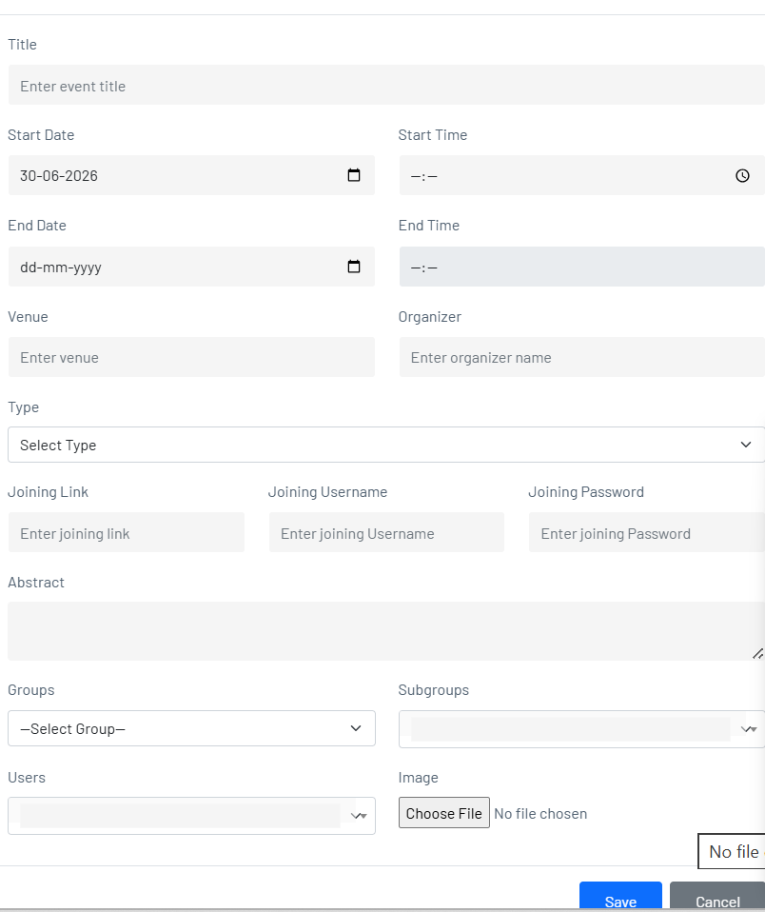
- Save and publish the event.

